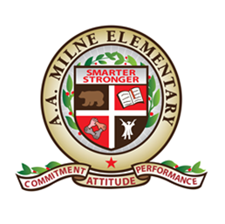 Milne Elementary School

7800 Portal Dr., Houston, TX 77071 Phone: (713) 778 3420

Principal Bronchelle Johnson

**School Uniforms**

**Uniformes Escolares**

Tops **(PK-2nd)**: black polo shirt Tops **(3rd-5th)**: red polo shirt

Camisas con cuella **(PK-2nd):** negro Camisas con cuella **(3rd-5th)**: rojo

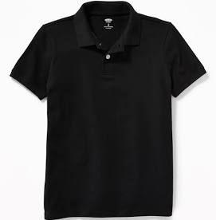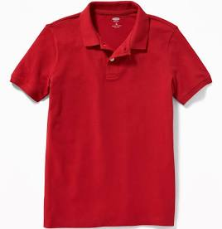

**Pants, Skirts, or Shorts:** black, navy, or khaki

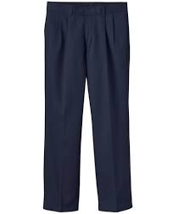**Pantalones, Faldas, o Pantalones corto:** negro, azul marino, o khaki

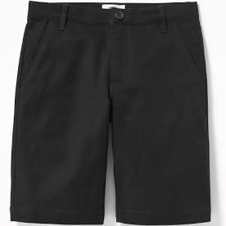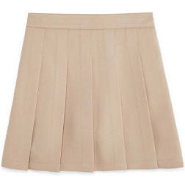

**Fridays/Viernes**: school spirit aguardiente escolar/college shirts camisas de la Universidad **\**no ripped jeans allowed/no se permiten vaqueros raspados\****

